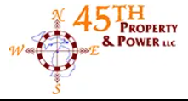 45th Property & Power
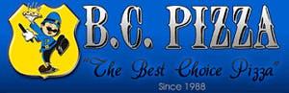 B.C. Pizza
Bulls-i Marketing
Firehouse Subs
GoGo Squeeze
Grand Traverse Deputies
GRIT Shop
Grand Traverse Refrigeration
3West Commercial Real Estate
J.R. Law
J&S Project Feed the Kids
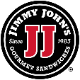 Jimmy John’s Gourmet Sandwiches
Legacy Legal Group, PLC

Mission Water Treatment
Northwest Well Works
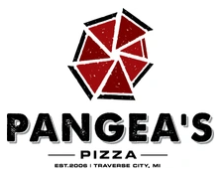Pangea’s Pizza
Pizzarama
Play It Again Sports
Reichard & Hack – EXIT Realty
Smyka’s Drill Team
TC Counseling
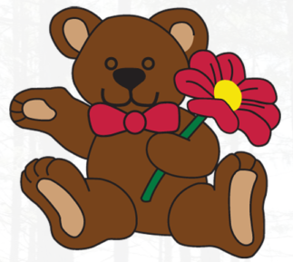 TeddyBear Daycare & Preschool, LLC
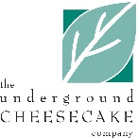 The Underground Cheesecake Co.
Threads
Traverse Bay Area Credit Union
TKS

