Aunt Tara’s Creative Canine Solutions
Bayside Allergy
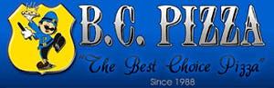 B.C. Pizza
Bulls-i Marketing
Centennial Wealth Advisory
ColdwellBanker/Woodland Title
Team Elmer’s
Firehouse Subs
GoGo Squeeze
Grand Traverse Deputies
GRIT Shop
Grand Traverse Refrigeration
3West Commercial Real Estate
JoMo’s Ice Cream Shop
J.R. Law
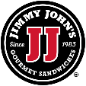 Jimmy John’s Gourmet Sandwiches
North Coast Legal, PLC
Northwest Michigan Health Services
O’Hearn Pest Control
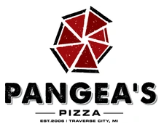Pangea’s Pizza
Play It Again Sports
Quantum Sails
Reichard & Hack – EXIT Realty
Jeff Skomp – Coldwell Banker
TC Counseling
Threads
Traverse Bay Area Credit Union
TKS

