Killeen Allstate
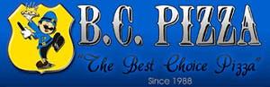 B.C. Pizza
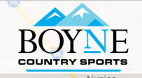 Boyne Country Sports
Bulls-i Marketing
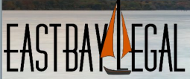 East Bay Legal
Edward Jones
Fiber North, Inc.
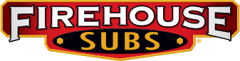 Firehouse Subs
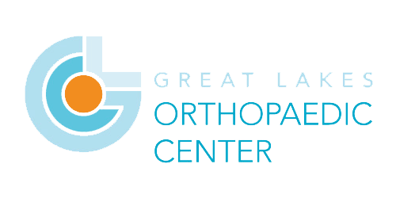 Great Lakes Orthopedic Center
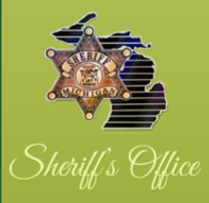 Grand Traverse Deputies
GRIT Shop
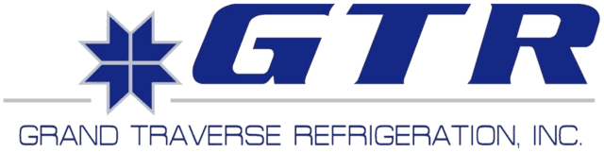 Grand Traverse Refrigeration
Honor Bank
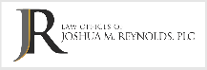 J.R. Law
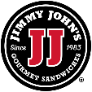 Jimmy John’s Gourmet Sandwiches
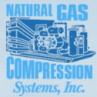 Natural Gas Compressions
North Coast Legal, PLC
Once Upon A Child
Play It Again Sports
Quantum Sails
Reichard & Hack – EXIT Realty
Sonny’s Body Shop
Stanley Steemer
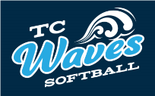 TC Waves
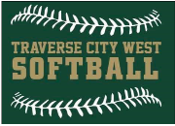 Traverse City West Softball
Threads
Twin Bay Glass

